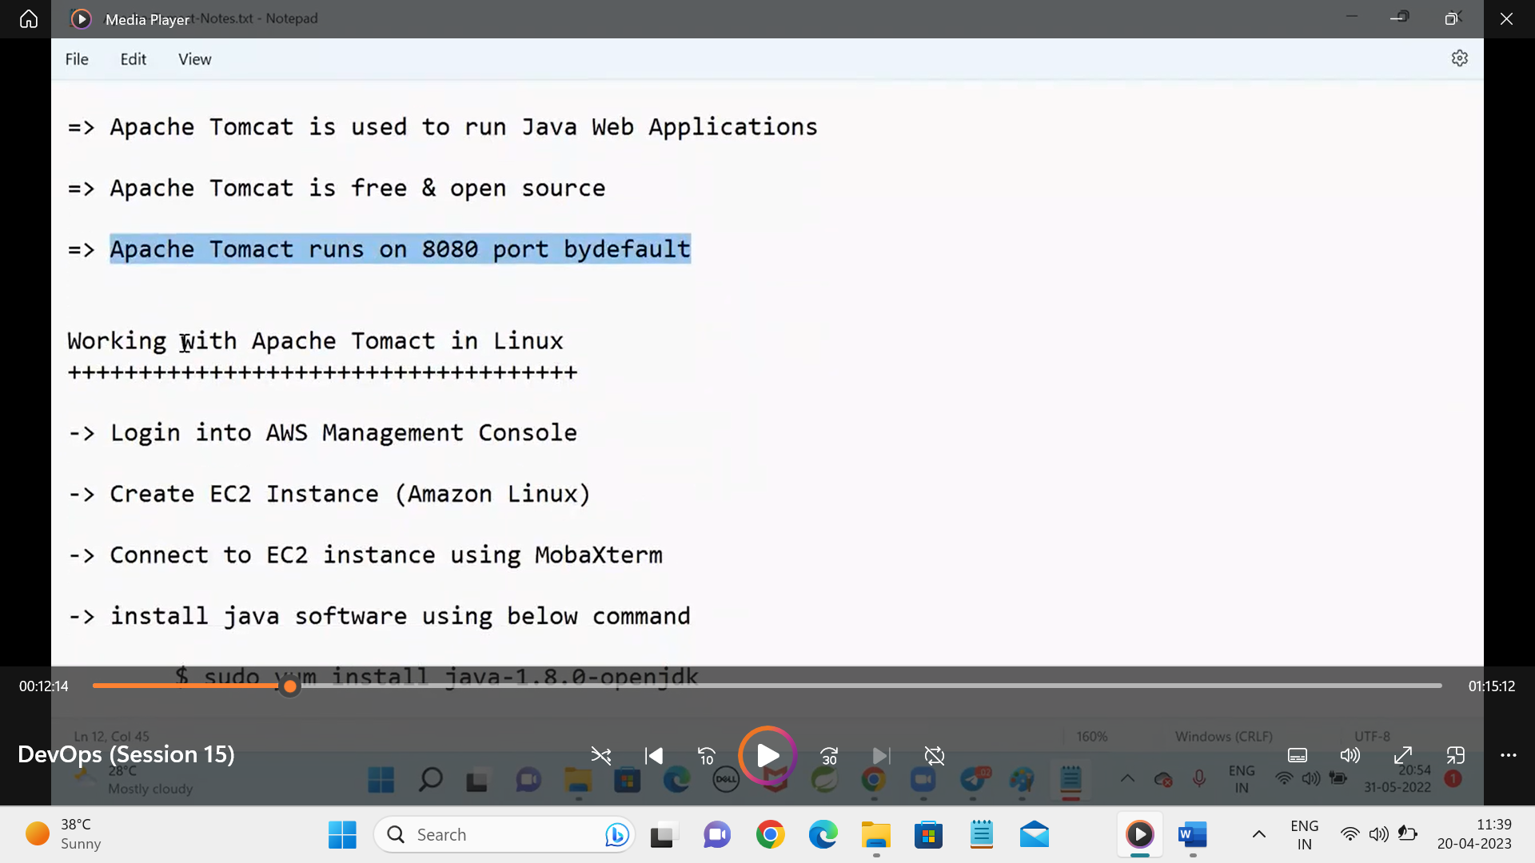

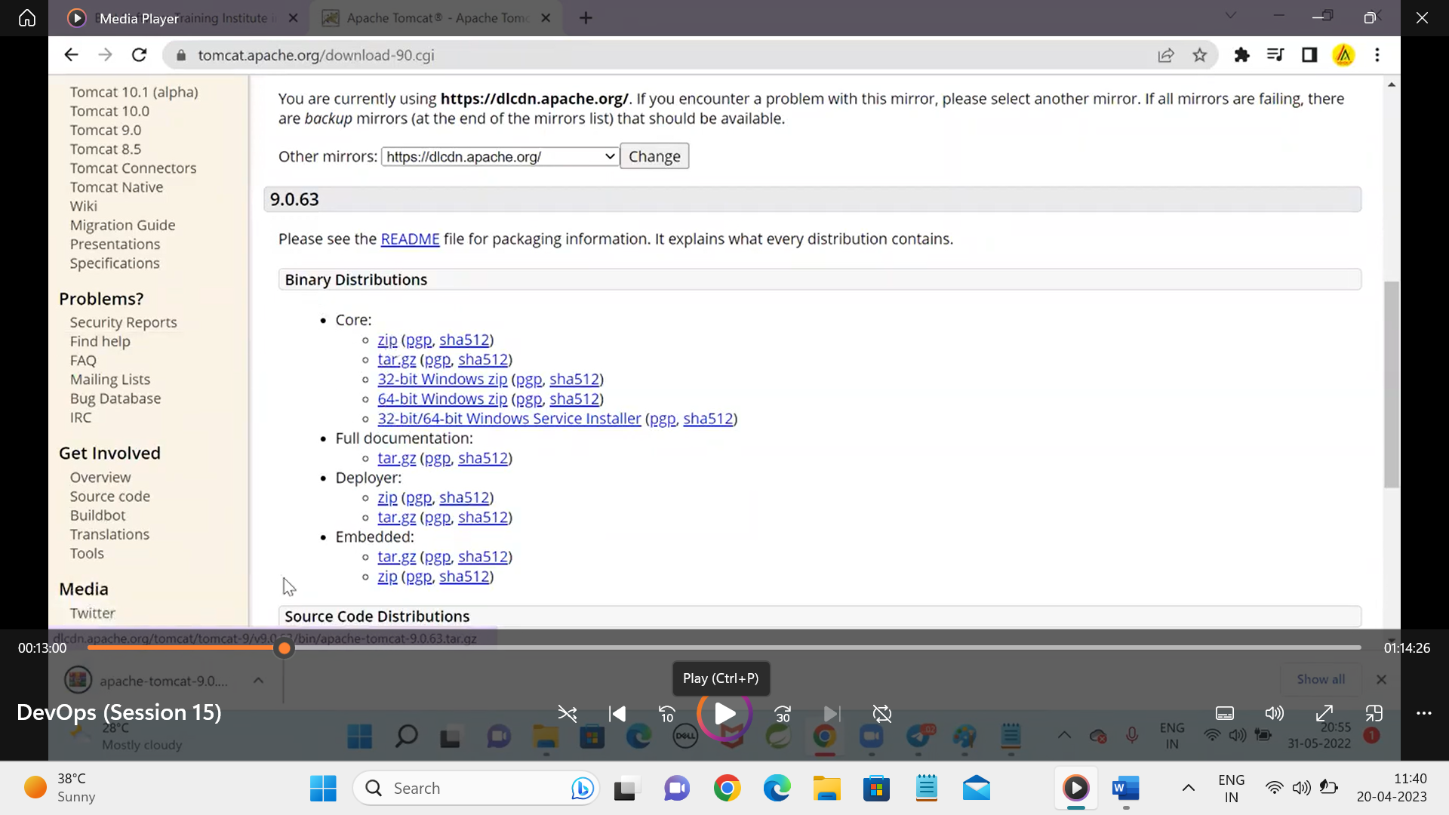

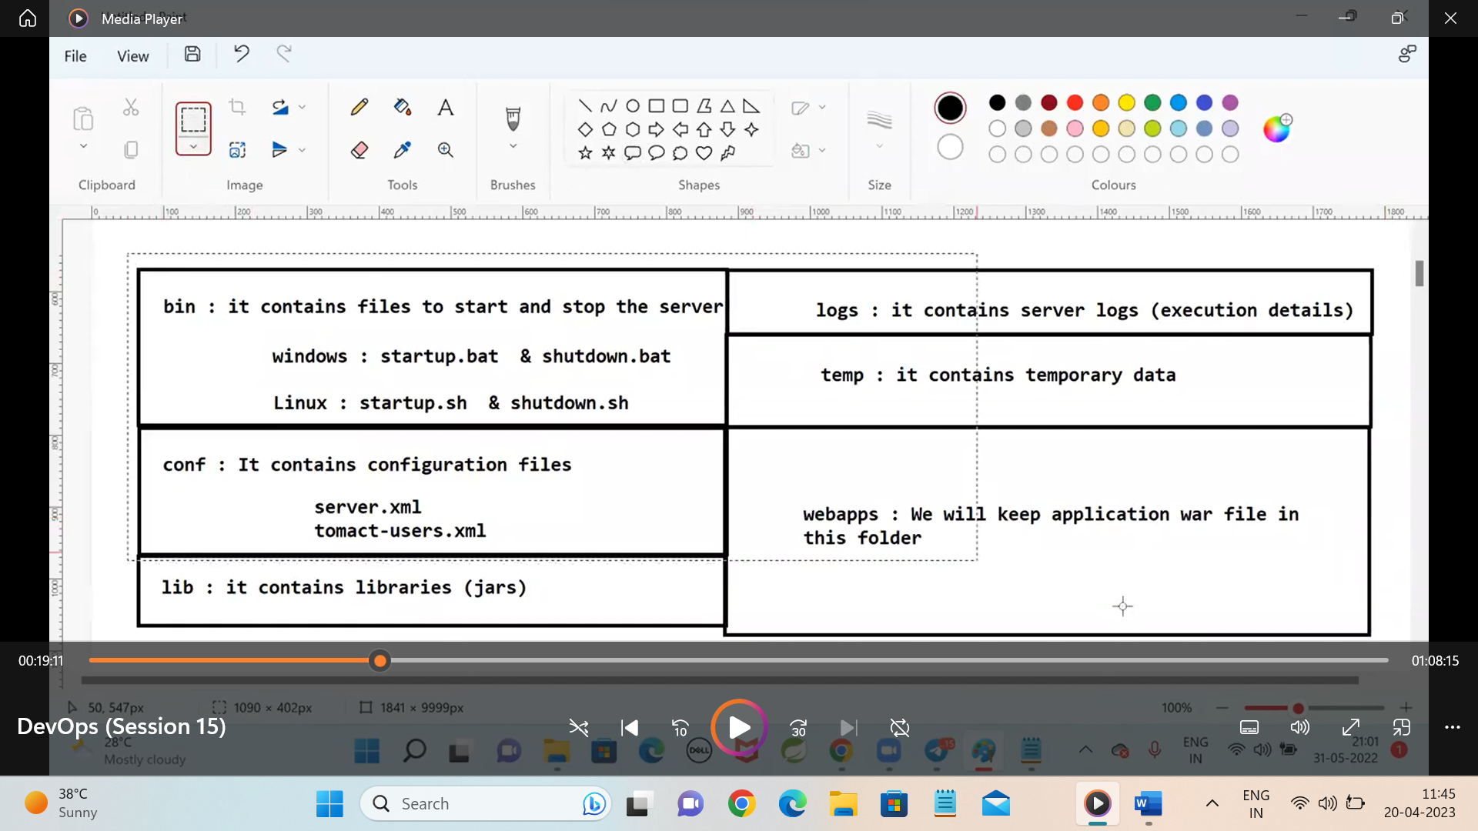

**We can keep our war files in the webapps folder we can keep multiple files in the the webapps.**

**In server.xml we can change the port number of the tomcat server basically the server of the tomcat is 8080**

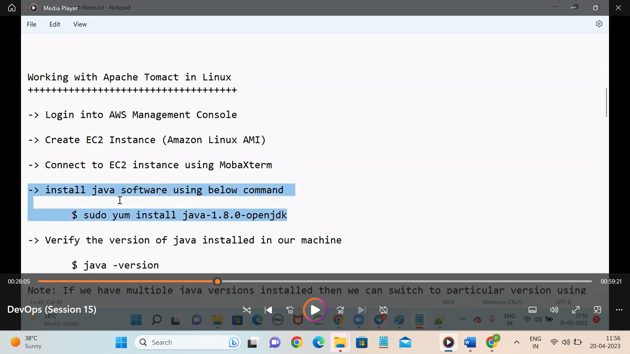

**In aws install the java for tomcat and maven the java should be there and we have multiple versions of java so we can use them we have command to do.**

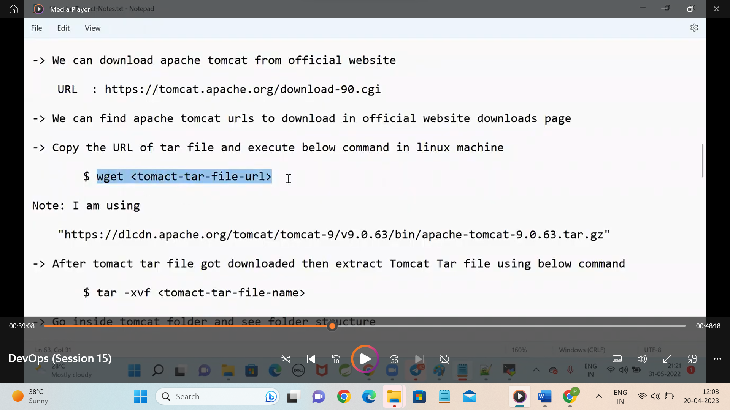

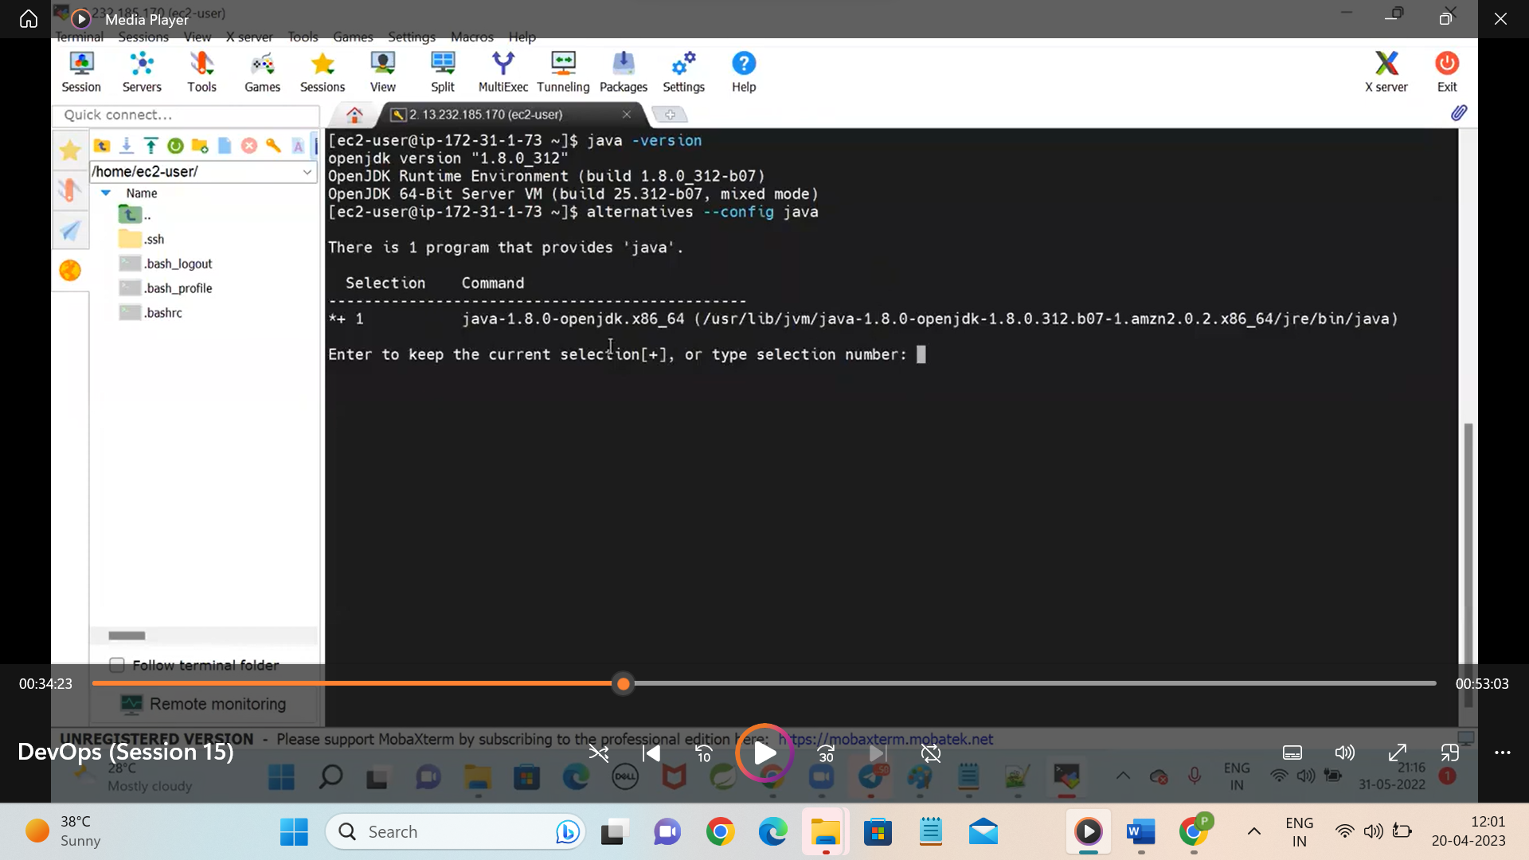

We have installed the java in the ec2 server and we have installed the apache tar file in the ec2 instance.

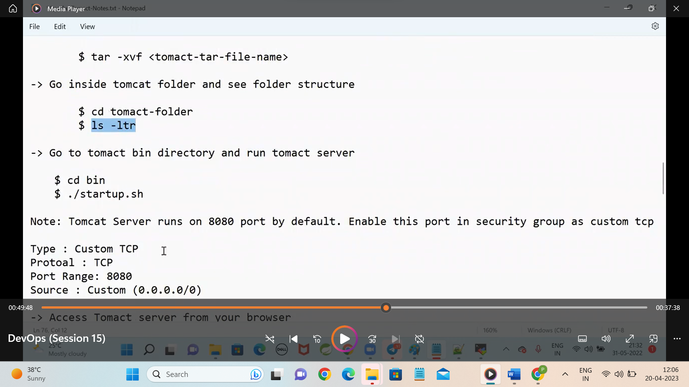

We have tomcat installed in vm but we can acess from browser but we cannot deploy from the laptop so we have the solution

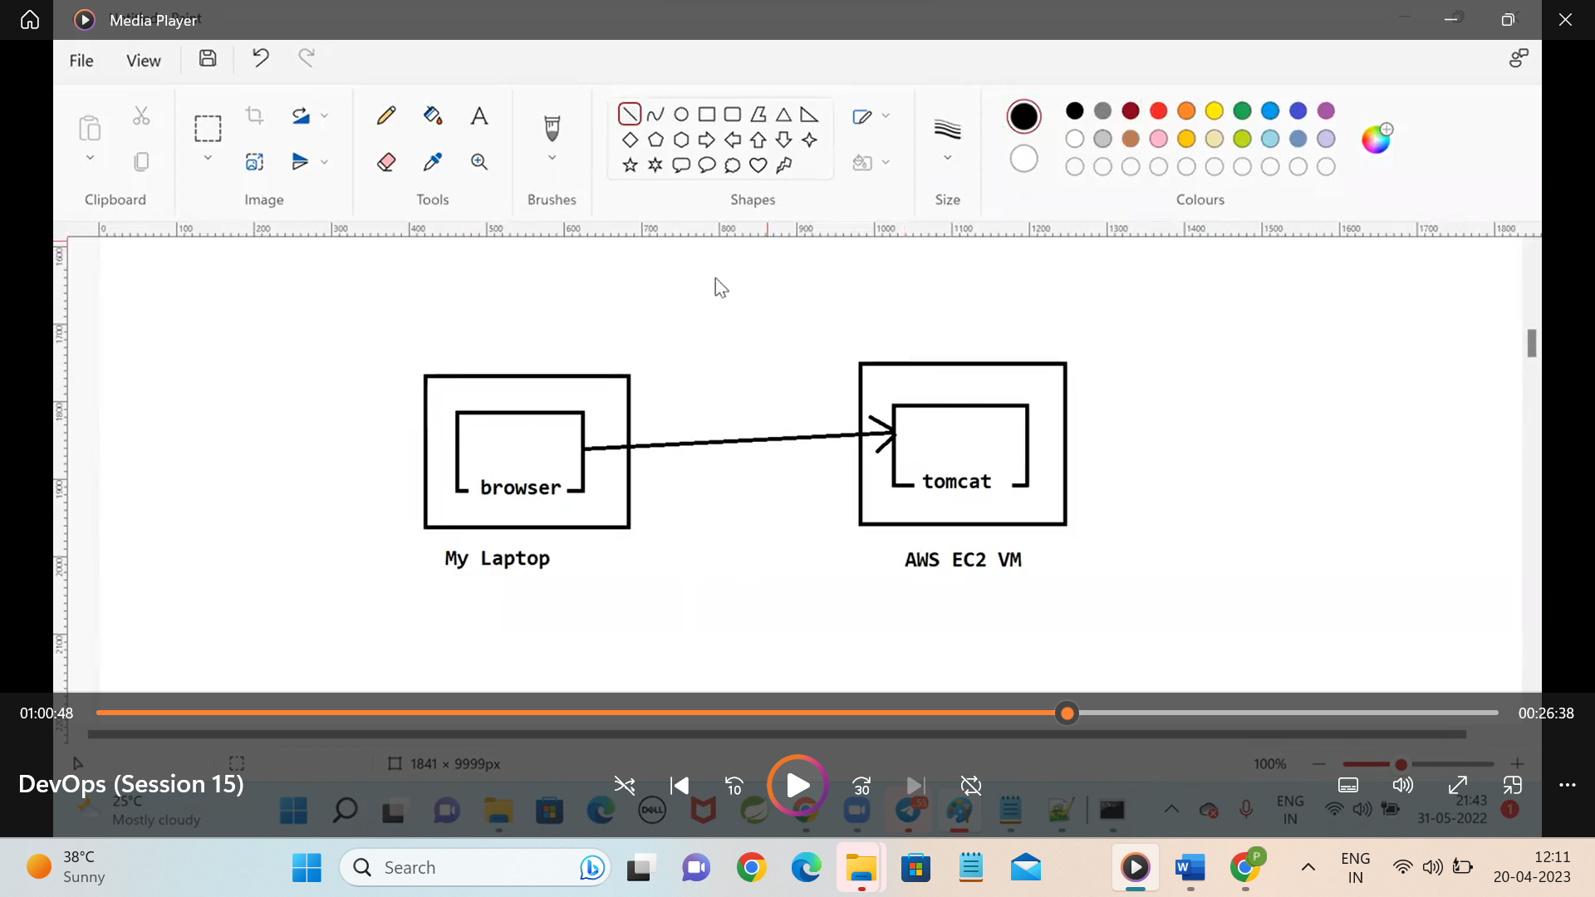

If we make the changes as above then we can allow the particular person ip address

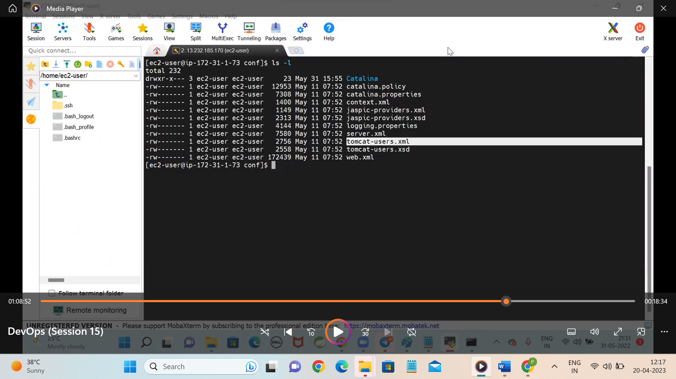

Then we will configure the uses for the tomcat in a specific location in conf

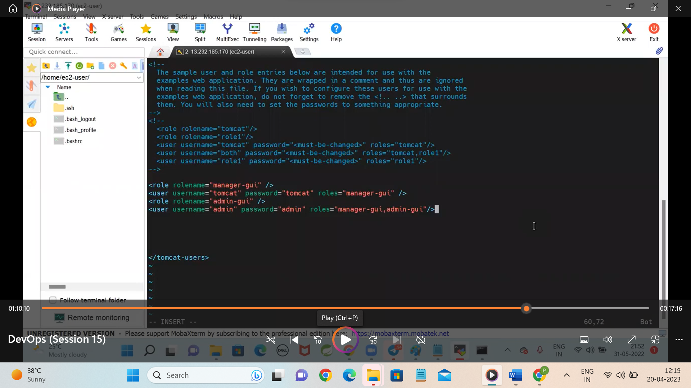

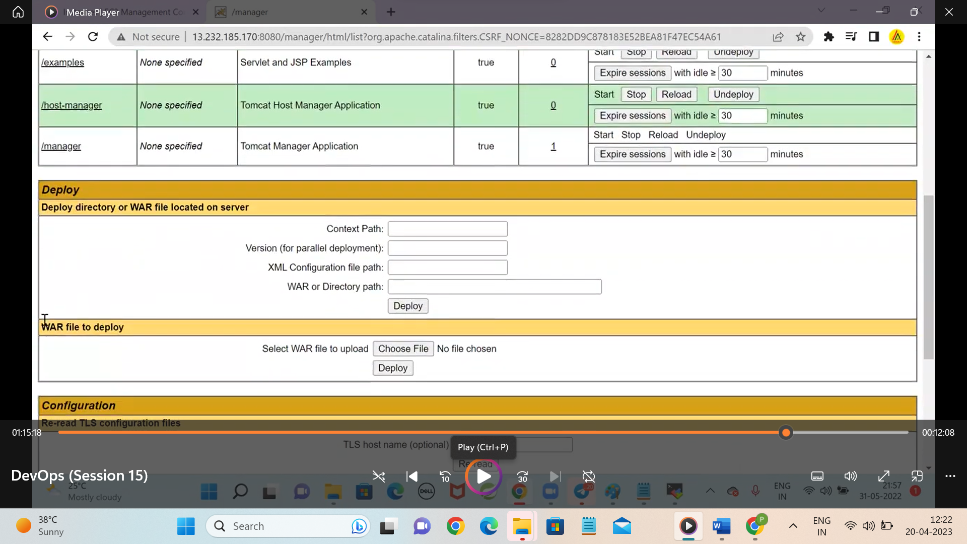

Build the maven war file using this

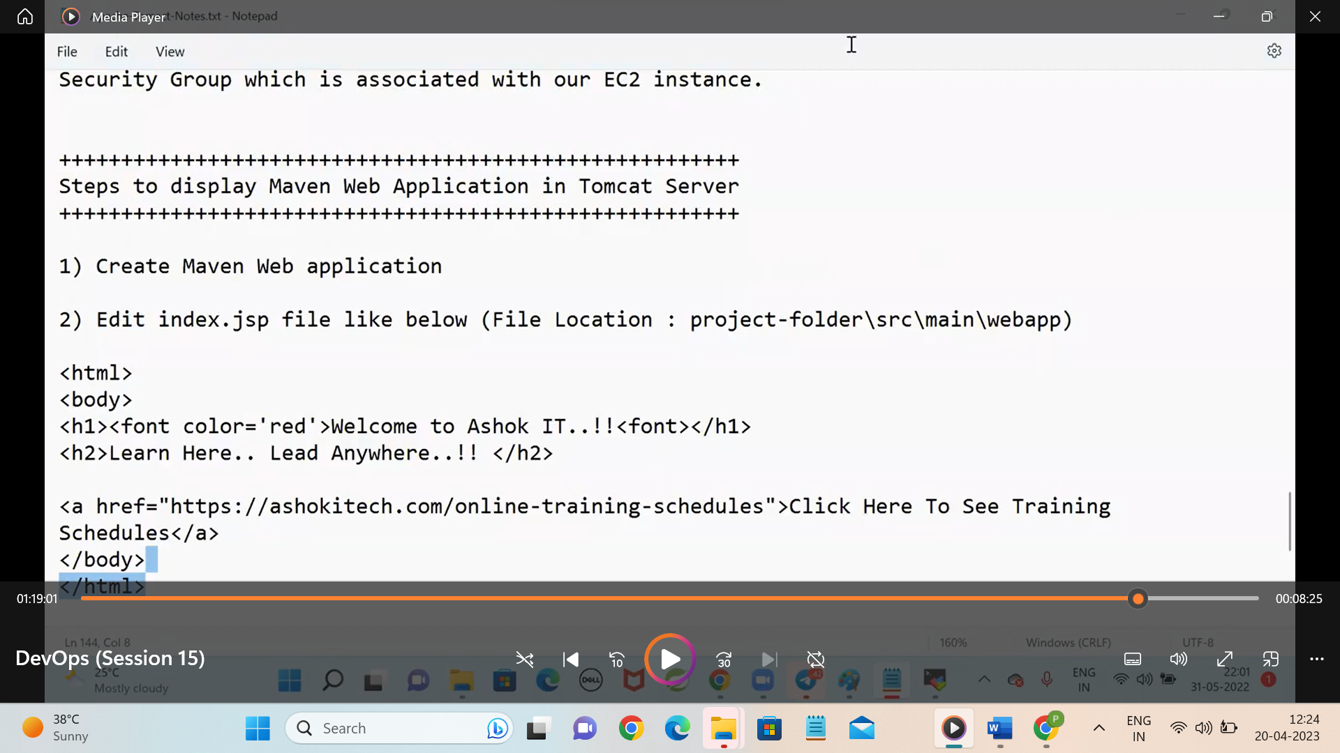

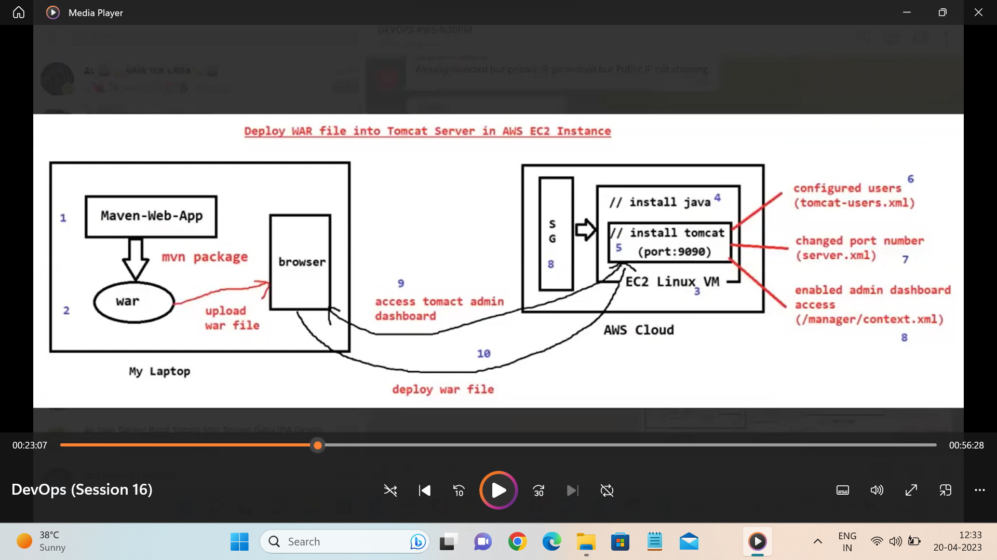

Imp link

https://github.com/ravdy/DevOpsDemos/blob/master/Tomcat/tomcat_installation.MD

